
Lockney
Little League
Safety Plan
2025
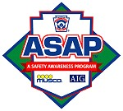
League ID: 00293978
TABLE OF CONTENTS
Introduction 1
Emergency Contacts 2
Emergency Procedures 3
First Aid 4
Training 4
First Aid Kits 4
First Aid Tips 5
Minor Cuts / Abrasions 5
Bee Stings 5
Minor Sprains and Contusions 5
Accident / Incident Reporting Procedures 6
What to report 6
How and when to report 6
Incident follow-up by the Safety Officer 6
Volunteer Background Check 7
Training 8
Baseball Fundamentals 8
Umpires 8
Equipment 9
Facility Survey 9
Managers And Coaches 10
Game and Practice Activities 10
Bat Safety 11
Batting Cages 12

Lightning Safety 13
Concession Stand Safety 15
Cooks 15
At Closing 15
Counter Workers 16
Covid Mitigation 17
Appendix A – Board of Directors 18
Appendix B – Incident/Injury Tracking Report 19
Appendix C – Facility and Field Inspection Checklist 20
Appendix D – Field Maps 21

INTRODUCTION
The purpose of the Lockney Little League Safety Plan (LLLSP) is to provide a systematic approach to promote the safety of all players, volunteers, and spectators. It focuses primarily on injury prevention through the education of coaches and managers, player conditioning, health awareness, and proper maintenance of fields and equipment. When injuries do occur, this plan provides guidance on treatment and reporting procedures.
The Safety Officer prepared this Safety Plan with the assistance of other members of the Lockney Little League (LLL) Board of Directors. It will be posted on the website and distributed to all board members, managers, coaches, and division coordinators. A reference copy will also be available in the concessions stand.
Safety is EVERYONE’S responsibility. Parents are urged to discuss any practice or gamerelated safety concerns with their child’s team manager, coach, or the Coaching Coordinator. (See Appendix A – Board of Directors for a complete list of all LLL Board of Directors). Any issues that cannot be readily resolved should be raised to the Board of Directors through the Safety Officer.
Managers and coaches please review this plan carefully and follow it closely. If you have any questions, concerns, or suggestions please discuss them with your division coordinator or the safety officer, as appropriate. Complete contact information is included in Appendix A – Board of Directors.
Let’s have a fun, safe and awesome season!!!


EMERGENCY CONTACTS

Ambulance/Fire/Police – Dial 911
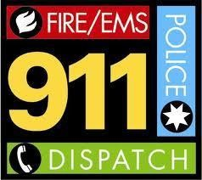
In any police, fire, or medical emergency, Dial 911 first
Give information and location to the Operator
Notify a parent or guardian
For medical emergencies involving a player or other child, notify their parent(s) or guardian. Each team manager must maintain a list of emergency telephone contacts for every player on his/her team and have it readily available during all team games and practices. It is recommended that these numbers be added to each manager/coach’s cell phone contact list.

Notify the League President and League Safety Officer
Every emergency resulting in a 911 call or any other event that could reasonably result in filing an insurance claim, must be reported (via phone) to both the League President (J.J Morales) and the League Safety Officer (Johnny Arjona) as soon as practicable but no later than 48 hours after the incident occurs. An Accident / Incident Report Form must be completed and placed in the Concession Stand.
J.J. Morales, LLL President - 806-781-7678
Johnny Arjona, LLL Safety Officer - 806-292-1037

EMERGENCY PROCEDURES
In any medical emergency involving a player, volunteer, or spectator dial 911 immediately.
Medical emergencies include, but are not limited to: o loss of consciousness or severe head trauma
- an injury that could reasonably include spinal injury or paralysis o signs of heart attack or stroke (heat)
- compound fractures (broken bone penetrating the skin)
For serious injuries that do not constitute emergencies, the team manager should consult with the parent or guardian, if possible, to determine the preferred course of treatment.
If no parent or guardian is available, error on the side of caution by calling 911 for professional assistance.
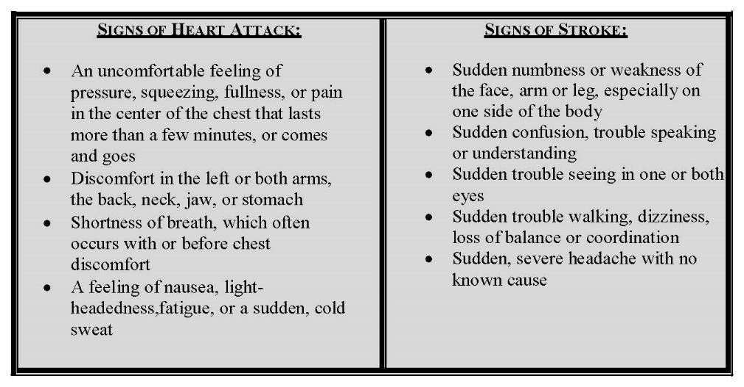

FIRST AID
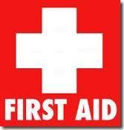

Training
Lockney Little League and local First Responders provide first aid training and CPR, as outlined in this manual for managers and coaches. First aid training will be included in the coach’s clinic.
Attendance by at least one manager or coach from each team is MANDATORY.

First Aid Kits
Basic first aid kits will be available in the concession stand, which is accessible by all coaches, managers, and volunteer staff during practices and games. First Aid Kits will be reviewed by local medical personnel on a yearly basis and when notified of usage.
It is particularly important to notify the League Safety Officer if any items have been used out of the First aid kits for a prompt replacement.

AED
A Zoll automated AED will be available in the concession stand and all coaches and umpires will be knowledgeable in its location and use. It will have 1 pediatric and adult pads and located in a labeled AED storage box. Signage will be placed outside indicating an AED is located within the building.

First Aid Tips
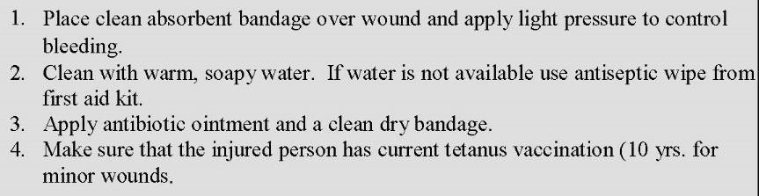
Minor Cuts / Abrasions

Bee Stings

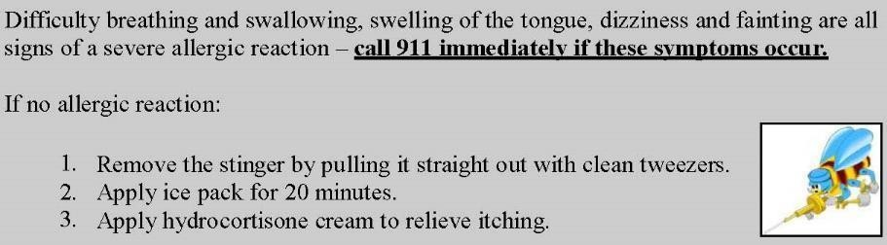
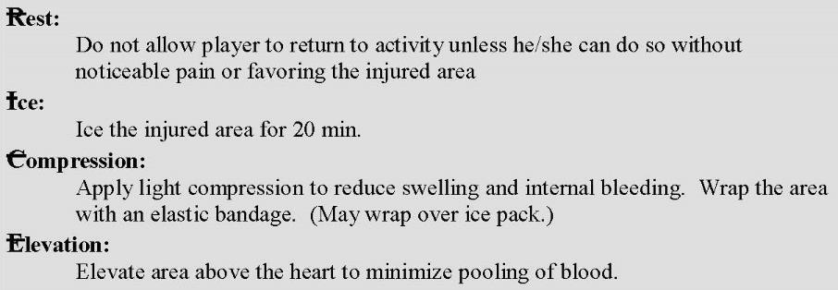
Minor Sprains and Contusions

ACCIDENT / INCIDENT REPORTING PROCEDURES

What to report
Report ANY accident / incident that requires first aid or professional medical treatment, whether rendered on or offsite, to the Safety Officer.
Report “near misses” to assist the LLL Board in identifying potential areas of concern to avoid any future injuries.
For injuries to players, the team manager is responsible for filing the report.
For injuries to volunteers or spectators, any league official who renders assistance should file the report.

How and when to report
Complete the Accident / Incident Report Form located in Appendix B – Incident/Injury Tracking Report of this Safety Plan.
All sections of the form should be completed.
In the event of an emergency, ensure that the contact information is completed prior to placing them in the concession stand Safety folder.
Incidents should be reported to the Safety Officer as soon as possible but no later than 48 hours after they occur.

Incident follow-up by the Safety Officer
Within 48 hours of receiving an incident report, the Safety Officer will contact the injured party or his/her parents to:
o Check on the status of the injured party o Verify the information received in the incident report o Obtain supplemental information as necessary
In the event that the injured party required professional medical treatment, advise the parent of Lockney Little League’s insurance coverage and the procedures for submitting claims. The Safety Officer will make periodic follow-up calls, as necessary, until the incident can be considered closed.

VOLUNTEER BACKGROUND CHECK
All Lockney Little League volunteers whose duties include working with or supervising the activities of children must complete the Official Little League volunteer application form attached to the back of all sign-up packets and available upon request from the LLL Board of Directors.
That form, along with a photocopy of a valid driver’s license or government-issued photo ID card, must be provided to the Safety Officer for verification.
The Safety Officer will complete a national criminal and sex offender background check for each volunteer.
Any person who has been convicted of any sex crime, appears on any list of sex offenders, or has been convicted of any felony offense WILL be prohibited from serving in any volunteer capacity with the league. There are NO EXCEPTIONS to this rule.
Any person who refuses to submit a complete volunteer form for any reason WILL also be prohibited from volunteering.
Volunteers who must undergo background checks include:
▪ ALL members of the Board of Directors
▪ Managers/ Assistant Coaches
▪ Team parents (Any parent assisting with practices or games)
▪ License, for identification BEFORE providing service to the team or LLL.
▪ Concession workers
▪ Umpires
Other volunteers (including concession stand workers, and field maintenance personnel) will not routinely be required to submit the volunteer application.
The LLL Board of Directors reserves the right to request a completed application and to run a background check on any volunteer.
The LLL Registration Coordinator will provide a complete list of managers and coaches in their league to the Safety Officer for verification that background checks have been completed.
Until the Safety Officer certifies that a background check has been completed, that person may not serve as a manager, coach, or volunteer helper in any LLL practice or game. There are no exceptions to this rule.
LLL reserves the right to prohibit volunteer service for other offenses identified in the background check that the Board of Directors feels poses potential risk or harm to the players, other coaches or spectators of LLL.
Volunteer forms and results of background checks will be retained for the year by the LLL Safety Officer.
A copy of this safety plan shall be provided to all volunteers and will be retained in the concession stand.
7

TRAINING

Baseball Fundamentals
Teaching proper baseball skills and techniques to young players enhances their enjoyment of the game while promoting player safety. Toward that goal, Lockney Little League provides a Coach’s Clinic for all coaches and managers.
Training will cover all aspects of conducting an effective practice, including hitting, sliding, fielding, pitching, proper stretching, and warm-up. All coaches and managers are encouraged to attend this excellent clinic.
Training time will be held before the first practice (April 2025) and posted on the website.
Attendance by at least one manager or coach for each team in MANDATORY when available.
Each manager or coach must attend this training at least once every 3 years.

UMPIRES

All umpires are required to use the following safety equipment:
o Chest protectors. o Shin guards. o Masks. o Protective cup for male umpires (personally provided).
LLL provides Umpire Equipment or Umpires may use their own.
Introductory training will be provided at a date and time to be announced by the Umpire Coordinator.
Any incidents (ejections, etc.) occurring that require umpire intervention should be reported to the appropriate Division Coordinator.
EQUIPMENT
The league’s equipment manager will inspect all helmets, catcher’s gear, and bats prior to the start of the season.
Managers and/or coaches should inspect the equipment prior to each game.
Never allow a player to use defective or improperly fitting equipment Repair damaged equipment if possible.
If you are not able to complete the repair, return the equipment to the Equipment Manager for repair or replacement by placing it in the Concessions Stand and notifying the equipment manager using the contact information in the Safety Plan.
Damaged equipment that cannot be repaired (e.g., cracked helmets) WILL be immediately removed from service and, if possible, physically destroyed to prevent their subsequent reuse by others.
All destroyed equipment will be identified by the equipment manager and reported to the Board of Directors.

FACILITY SURVEY
The Facility survey will be done annually and sent in electronically.

MANAGERS AND COACHES
Managers and coaches are the individuals primarily responsible for ensuring the safety of the players. The following procedures should be practiced until they become a routine part of your practice and game day activities.

Game and Practice Activities
Prior to each game or practice, the manager or coach is responsible for walking the field looking for unsafe conditions. A Safety Checklist must be completed by the Safety Officer, once monthly, and placed in the concession stand, and is included in Appendix C – Facility and Field Inspection Checklist of this Safety Plan. This might include broken glass or other foreign objects, holes in the ground, damaged fences, etc. Necessary repairs should be completed before allowing a game or practice to begin. If repairs are not possible prior to a scheduled game, that game must be postponed and the Safety Officer (see Appendix A – Board of Directors) notified immediately. All dirt surfaces should be reasonably smooth and free of holes or other conditions likely to cause “bad hops.” If necessary, rake or drag the dirt to level the surface. (This should have been done after the preceding game.)
Do not allow players to throw baseballs or swing bats in any off-the-field locations that could endanger other players or spectators.
Such warm-ups, when necessary, should be conducted away from pedestrian and spectator areas. Be especially aware of the potential consequences of an overthrown ball.
Inspect equipment for signs of damage that would make it unsafe.
Each team should have at least 4 helmets of various sizes on hand. Inspect the helmets for cracks or inadequate padding. Unsafe helmets should be destroyed. Notify the equipment manager so that replacements may be obtained as necessary.
Ensure that catcher’s equipment is in good condition and that all male catchers are wearing protective athletic cups. The catcher’s mask must include a dangling throat protector. Ensure that the catcher wears the mask during pre-game batting practice and when warming up pitchers, as well as during the game.
Little League Rules will be enforced at all practices and games. Pitchers are required to warm up with catchers only; coaches will not be permitted to warm up pitchers (Rule 3.09) All bases will be examined for proper disengagement prior to practices and games.
Ensure that all jewelry is removed by players. No jewelry of any kind may be worn during games and practices. This includes neck chains, earrings, rings, bracelets, and plastic “Livestrong”-type wristbands. Encourage players to leave all jewelry at home.
Include at least 10 minutes of progressive warm-up time prior to each practice or game. Players arriving late should be required to warm up properly before participating in practice or game activities. Suggested warm-up activities include light jogging followed by light throwing at progressively greater distances.
Ensure that a first-aid kit and a list of emergency telephone numbers for each player are on hand. LLL recommends that a complete list of emergency contact telephone numbers be stored in each manager and coach’s cell phone for the duration of the season.
Keep players well hydrated. Especially in hot weather, give the players frequent “water breaks” during practices. During games, encourage players to drink plenty of fluids while in the dugout during the offensive half of the inning. Fluid intake should be limited to water or sports drinks for proper hydration.
Food is not allowed in the dugout. Bubble gum and Sunflower seeds are allowed with the coach’s approval. There is NO EATING during games.
After the game, the home team must drag and rake all infield dirt areas. Both teams must clean all trash from their dugout/bench area.

Bat Safety
Little League regulations prohibit practice swings by “on-deck” batters in Majors Division down through T-Ball divisions (including Softball). This includes all practices and games. Managers and umpires must strictly enforce this requirement. This prohibition includes the fenced-in areas adjacent to the dugouts where bats, helmets, and other equipment are typically stored.
Only bats approved by Little League International may be used. If you would like to know if a bat is approved, please check online at www.littleleague.org
When not in use bats belong in the bat rack or other designated storage area.
Bats should not be allowed loose in the dugout while a game is in progress.
Only players, Coach/Managers should be in the dugout all others should stay in spectator areas.
At no time should bats ever be swung in any area other than the playing field, batting cage, or other area set up by and directly supervised by a manager or coach for instructional purposes (e.g., batting tee or “soft toss” station).

Batting Cages
Only managers, coaches, or other responsible adults designated by the manager may pitch batting practice in the batting cages.
All batters must wear helmets.
Only one player may be in the batting cage at a time (except when picking up balls).
Do not allow anyone to “hang on” to the fence such that fingers could be injured by a batted ball.
No horseplay of any kind should be tolerated when using the batting cages.

LIGHTNING SAFETY

No practice or game should begin if lightning “bolts” can be seen or if thunder is plainly heard.
Once the game is underway, responsibility for suspending play rests with the umpire-in-chief.
Both managers must remain acutely aware of an approaching storm and should notify the umpire immediately if lightning is seen or thunder is heard.
If lightning is seen or thunder heard, suspend activities immediately and direct all players to seek a safe shelter.
When in doubt as to whether conditions are safe, the game should be suspended and the field and dugout areas should be cleared of all players and volunteers
Play may not resume until at least 20 minutes after lightning was last seen or thunder was last heard.
Since permanent shelter space is limited at the LLL complex, everyone should take shelter in a hard-top vehicle with the windows up.
No one should remain in the dugouts or any open area.
Lightning is highly unpredictable and can spread rapidly. If you are within 10 miles of lightning, you are in danger.
Ten miles is about the distance at which thunder can be heard under most atmospheric conditions.
If you hear thunder, you must suspend play.
Unusual atmospheric conditions can reduce the distance that thunder is heard to as little as 4 miles.
The absence of thunder cannot guarantee your safety.
If there are other signs (e.g., rapidly darkening sky and strong wind gusts) that a thunderstorm has approached within 10 miles, you should suspend play.
All lightning produces thunder.
Lightning can be seen over much greater distances than thunder is heard.
So-called “heat lightning” (non-distinct flashes near the horizon that are not accompanied by any audible thunder) is simply lightning striking at a sufficient distance that the distinctive lightning bolt cannot be seen and no accompanying thunder is heard.
This indicates that a thunderstorm is active in the region and should promote increased vigilance for signs that the storm is approaching. However, it does not indicate that the storm is close enough to pose an immediate threat. Distant “heat lightning” alone, in the absence of other signs that the storm has approached within 10 miles, should not result in an immediate suspension of play.
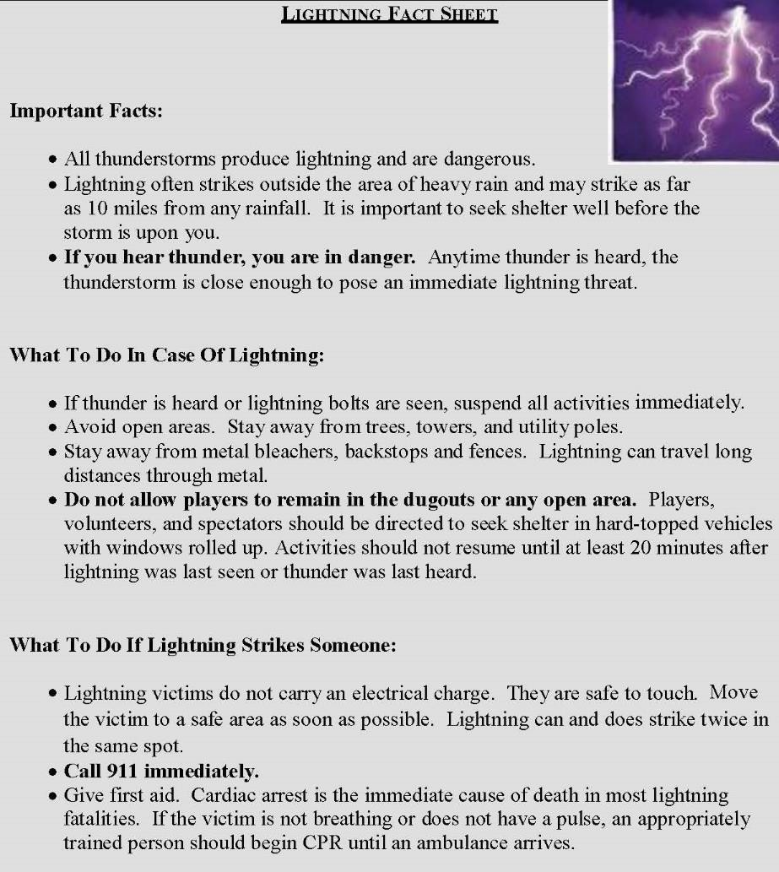

CONCESSION STAND SAFETY

The concessions stand supervisor on duty should familiarize all volunteers / employees with the location and operation of the fire extinguisher.
The concession stand supervisor is to be trained in safe food handling and/or preparation and procedures.
Children under the age of 16 are not permitted in areas around the grill when in operation or in a warm-up or cool-down mode.
Children under the age of 10 should not be in any area of the concessions stand. Concessions stand volunteers / employees should make other arrangements for supervising their children.
A first-aid kit and ice packs are available in the concessions stand at all times.

Cooks
Wash hands before touching food or food containers.
Do not take more meat out of the freezer than what will be cooked within 15 minutes.
Cook all hamburgers well done.
Be careful when putting food into the fryer. Splashed or splattered grease can cause serious burns.
Cooks should wear a clean, white apron.

At Closing
Clean countertops with an antibacterial cleanser.
Clean all cooking utensils in hot soapy water and place them in a rack to air dry.
Discard any leftover cooked food in a sealed bag.
Empty trash cans to the outside dumpster and place clean bags in all cans.
Ensure cooking appliances are unplugged or off as needed.

Counter Workers
Wash hands before beginning work. Dry hands with paper towels, not dishtowels.
Clean up spills, as they occur to prevent accidents. Re-wash hands after using any cleaning product.
Place all trash in the trash cans. Do not allow clutter to build up.

COVID MITIGATION
All attendees to Lockney Little League events, including practices, training sessions, meetings, and games, are encouraged to observe Centers for Disease Control and State of Texas guidelines for mitigation of Covid-19. This includes all coaches, players, umpires, volunteers, and fans.

APPENDIX A – BOARD OF DIRECTORS
 | Lockney Little League Board Members 2023
Role | Name | Address | Email | Phone
President | J.J. Morales | 509 SW 2nd street Lockney TX 79241 | Lilgiant2012@gmail.com | 806-781-7678
Vice President | Stacie Stoerner | 693 FM 2301 Lockney, TX 79241 | staciestoerner@gmail.com | 806-778-5339
Secretary | Victoria DeLaCerda | 610 SW 6th St Lockney TX 79241 |  | 806-983-1580
Treasurer | Meagan Vasquez | 609 SW 6th Street, Lockney TX 79241 | Meaganrae1014@yahoo.com | 806-402-0803
Player Agent, Facilities Coordinator | Ricky Vasquez | 609 SW 6th Street, Lockney TX 79241 | Vasquezricky0602@yahoo.com | 806-983-6478
Safety Officer | Johnny Arjona | 420 W Bryant Lockney TX 79241 | johnnyarjona@gmail.com
Umpire-in-Chief | Eduardo Salazar | 410 W Washington St, Lockney TX 79241 | slalo208@yahoo.com | 806-475-2769
Concessions Manager | JoAnn Gonzalez | 706 SW. 3rd street, Lockney TX 79241 | joanngonzalez95@yahoo.com | 806-292-5392
Equipment Manager | Carrie Rendon | 114 SW 7th St Lockney TX 79241 | carrierendon@gmail.com | 806-983-0214
Member | Michael Alaniz | 706 SW. 3rd street, Lockney TX 79241 |  | 806-983-4899
Member
Member
Member
Member
18

APPENDIX B – INCIDENT/INJURY TRACKING REPORT
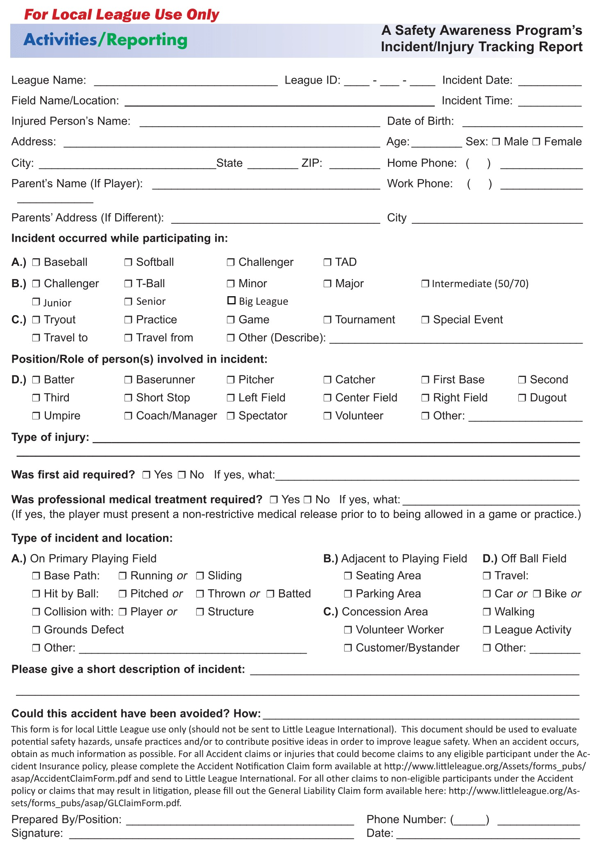

APPENDIX C – FACILITY AND FIELD INSPECTION CHECKLIST
Facility Name:
Inspector:
Date: Time:
- Holes, damage, rough or uneven spots o Slippery Areas, long grass
- Glass, rocks and other debris & foreign objects o Damage to screens, fences edges or sharp fencing o Unsafe conditions around backstop, pitcher’s mound o Warning Track condition
- Dugouts condition before and after games o Make sure telephones are available o Areas around Bleachers free of debris o General Garbage clean-up o Who’s in charge of emptying garbage cans o Conditions of restrooms and restroom supplies
- Concession Stand inspection
NOTES/HAZARDS

APPENDIX D – FIELD MAPS
Fields are located in Lockney, TX.
At the intersection of East Bryant street and East 8th street.
